More on Grep

1. Print all the lines having the word "pattern".

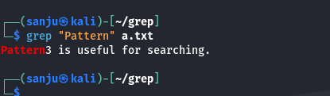

1. Pick out the blank lines in the file

1. Count total number of empty lines in the file.

1. Print the line which have both “Sir and Madam”.

1. pick out lines with “pattern1” “pattern2” or “pattern3”. (use the alternator |)

1. pick out lines that have at least two p's followed by any number of letters followed by 'ore'. The p's do not have to be next to each other.

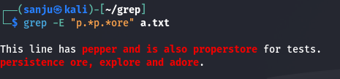

1. pick out all the lines that do not start with an uppercase letter.

1. pick out all the lines that end with a dash –

1. pick out all the words that end with ore

1. pick out all the words that start with f or F

1. pick out lines that uses first letter alliteration - starting two words with the same letter.

1. determine how many times contains the word "pattern".

1. to pick out lines with at least 40 characters:

1. to pick out lines with no punctuation

1. To pick out lines without rav

